**PROJECT-NAME : Myntra**

Submitted By,

Fathima Lameesa

Intern at Edureka

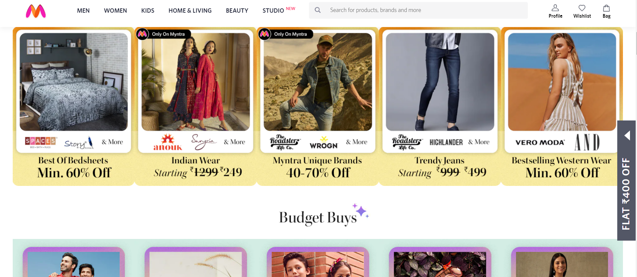

Overview:

A one shop for all your fashion and lifestyle needs. Being India's largest e-commerce store for fashion and lifestyle products, Myntra aims at providing a hassle free and enjoyable shopping experience to shoppers across the country with the widest range of brands and products on its portal. The brand is making a conscious effort to bring the power of fashion to shoppers with an array of the latest and trendiest products available in the country.

Page Structure:

1. HOME PAGE:

* features a lot of new items and promotions.
* discounted items on the homepage.
* icons for login/profile, cart.
* search bar, you can also specify your product search.
* Display Name of categories
* Filters or sorting option.

2)LOGIN PAGE:

Login by providing valid username, email id and password.

3)MAIN PAGE:

* Images of the choosen items
* Filters (cost, price, colour, size etc)
* Redirect to product page

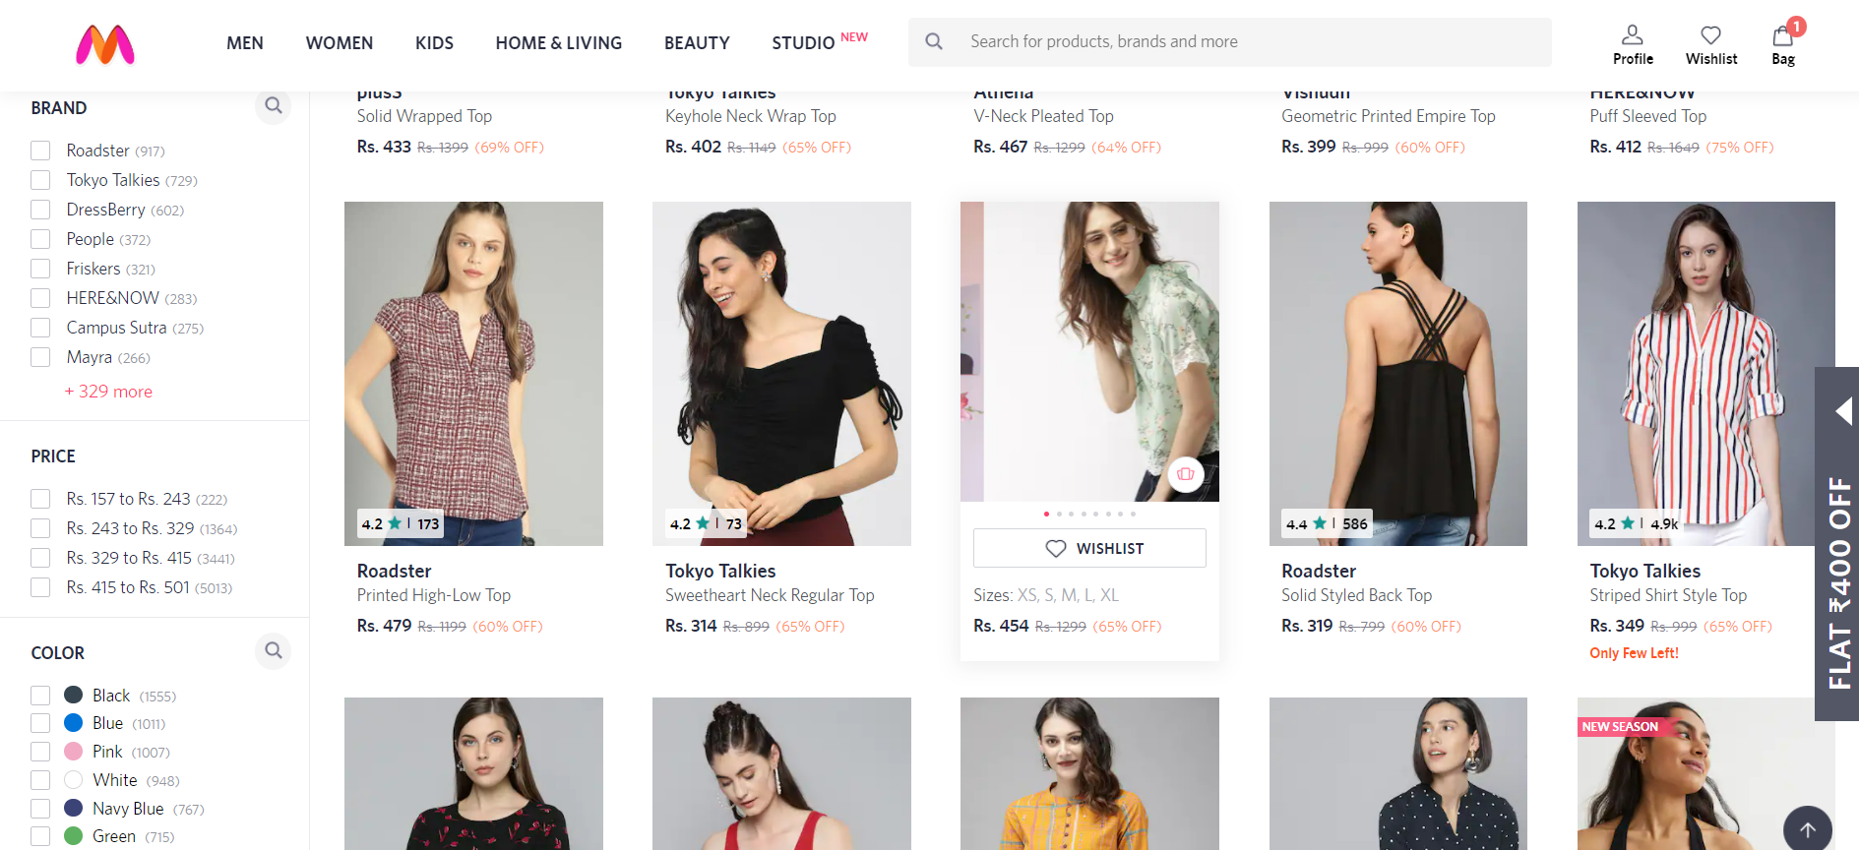

4)PRODUCT PAGE:

* Product Discription - BRAND, PRODUCT NAME, PRICE, DISCOUNT% (IF ANY)
* SIZE CHART
* RATINGS
* SIMILAR PRODUCTS

5)PAYMENT PAGE:

* Address details
* Mobile Number
* Payment Mode (COD, Net Banking)
* Listing Ordered Items